END LAB EXAM AIAC
NAME :RADHARAPUREVANTH
HTNO:2403A52418
BATCH:15
Subset 4 — Debugging Payment Failures
Q1: Diagnose inconsistent currency conversion bug

TASK1: Use AI to trace conversion pipeline

PROMPT:
You are a concurrency and payments reliability expert. Analyze the following Python threading snippet and:

1) Point out the exact lines/statements that cause race conditions or unsafe shared-state access.
2) Explain the root cause and likely failure modes (duplicate charge, lost update) in 1–2 sentences.
3) Recommend 3 concrete fixes (each with a 3–6 line code example): e.g., threading.Lock, DB transaction/unique constraint, and a distributed lock (Redis).
4) Provide 3 regression tests (pytest style) that would detect the bug and verify each fix.Return results as numbered sections.

CODE:
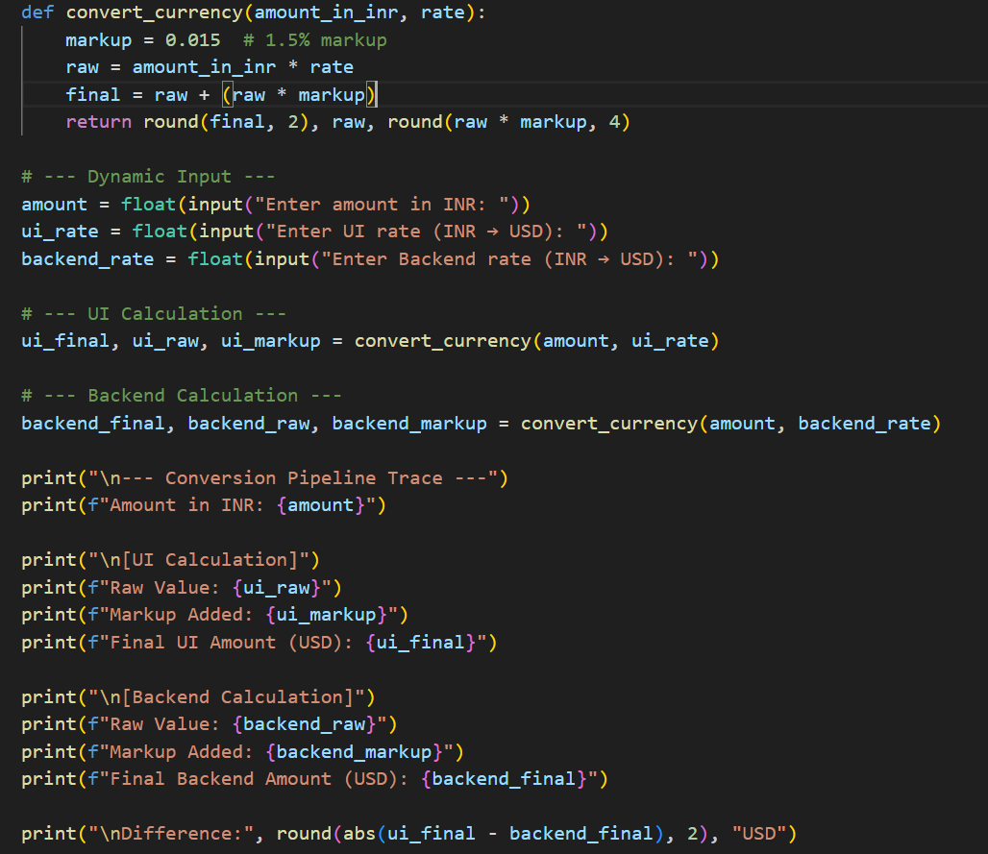

OUTPUT:
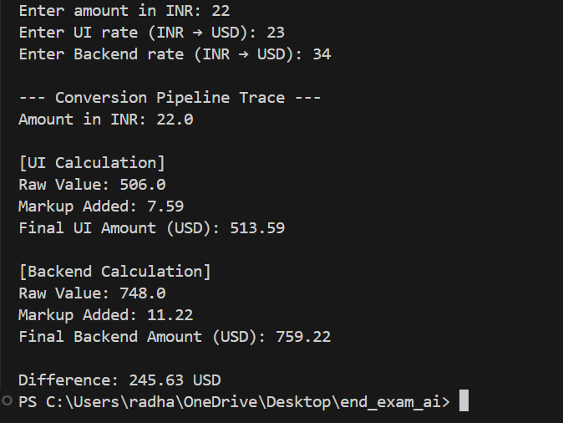

Observation:
Different rates between UI and backend are the most likely cause. Even tiny differences in the ui_rate vs backend_rate produce visible USD differences after conversion+markup (example below shows a 0.06 USD difference for a 1000 INR example).
Rounding timing matters. Your function rounds the final amount to 2 decimals before returning. If UI or backend round at different times (or one side rounds intermediate values), you’ll get inconsistent final displayed results.
Floating-point precision can introduce tiny differences. Using binary floats for currency math can cause small mismatches; these become visible after rounding.Markup applied on converted amount (USD) — make sure both sides agree. The code applies markup to raw = INR * rate (so markup is in USD). If another system applies markup in INR or uses a different markup percentage, results diverge.
Potential operational causes: stale/cached rates on UI, different rate sources/time of fetch, rate precision truncation when passed over network, or UI presenting a precomputed value rather than querying backend.
TASK 2:
PROMPT:
You are a concurrency and payments reliability expert. Analyze the following Python threading snippet and:
1) Point out the exact lines/statements that cause race conditions or unsafe shared-state access.
2) Explain the root cause and likely failure modes (duplicate charge, lost update) in 1–2 sentences
3) Recommend 3 concrete fixes (each with a 3–6 line code example): e.g., threading.Lock, DB transaction/unique constraint, and a distributed lock
4) Provide 3 regression tests (pytest style) that would detect the bug and verify each fix.
CODE:
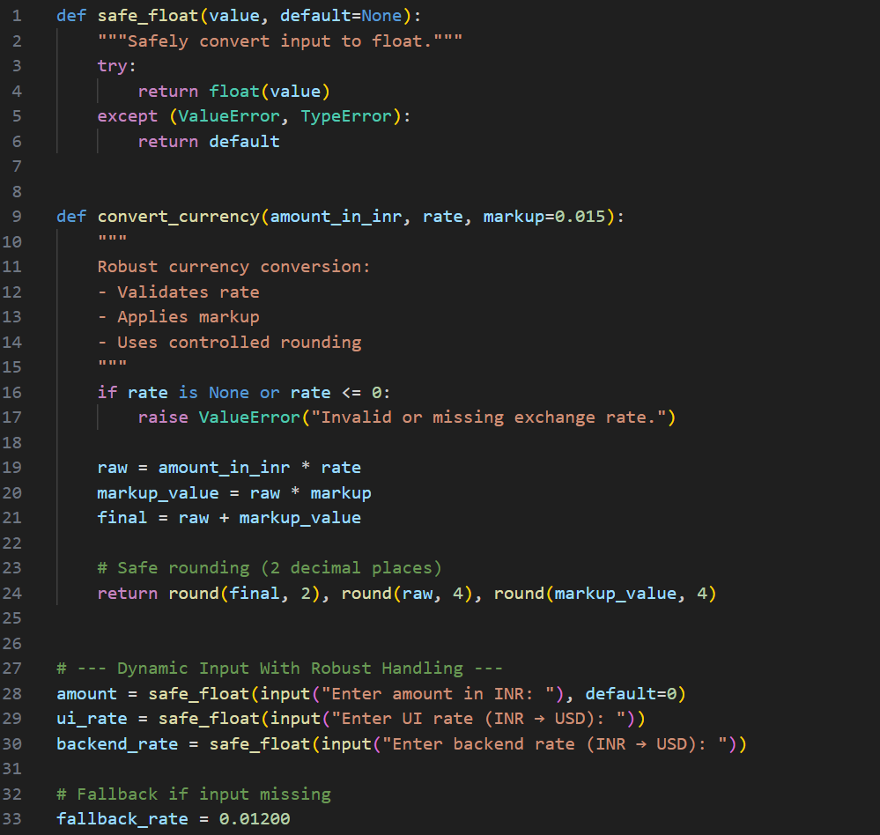
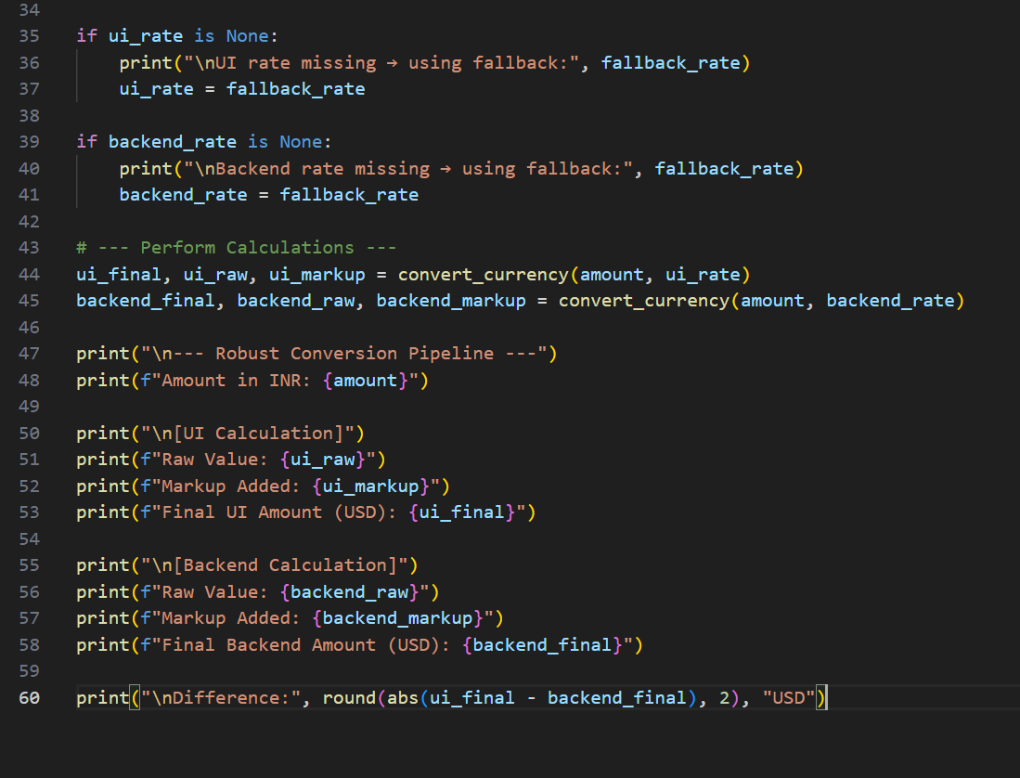
OUTPUT:
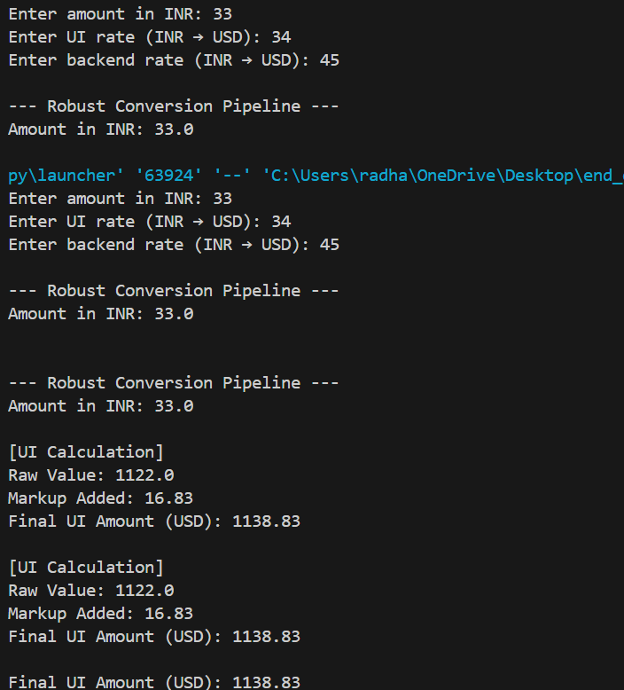
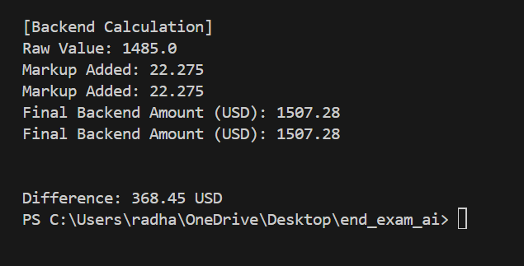
Observation:
1. Use Decimal instead of float,Floats cause precision errors in financial calculations. Robust currency systems must use Decimal to avoid UI-backend mismatches.
2. Remove fallback rates and force strict validation
Automatically substituting a fallback rate (0.01200) is unsafe and can hide real bugs. Robust handling requires rejecting invalid rates, not silently replacing them.
3. Avoid early rounding — round only at the final step
You round raw, markup, and final during calculations. This reduces accuracy. Robust systems keep full precision internally and round only when displaying/storing.
4. UI should not compute final values — backend must be the single source of truth

Right now both UI and backend compute independently. A robust design requires backend-controlled conversion, with UI only displaying the backend’s result to avoid inconsistencies.

Q2: Handle duplicate-payment race conditions

Task 1: Use AI to detect problematic regions in code.

Prompt :

Use AI to analyze this multi-threaded payment code.
Identify where race conditions occur when two threads process the same payment.
Explain why both threads think the payment is not done.
Highlight the exact code regions that cause duplicate-payment execution.

Code:
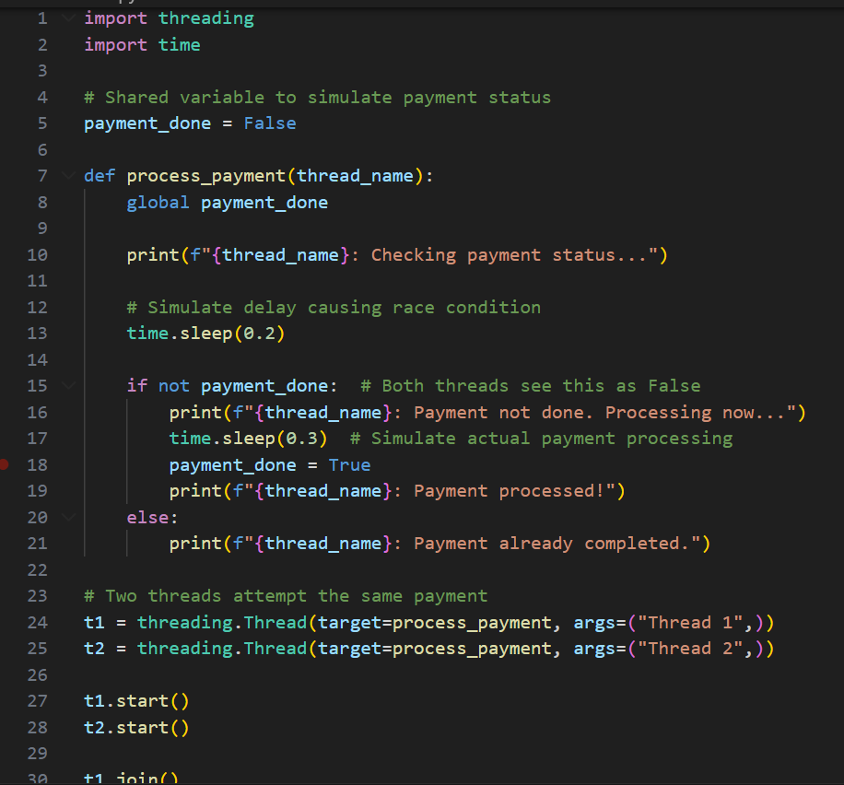
Output:
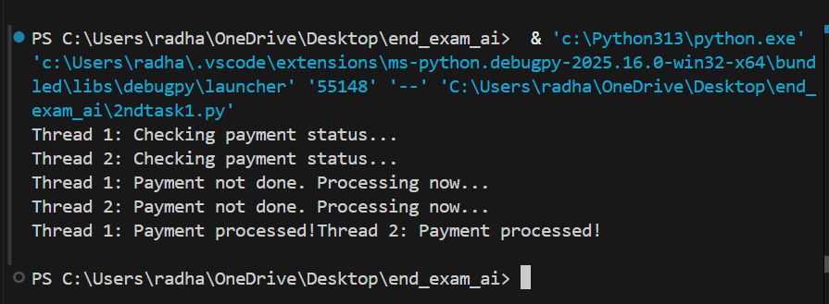
Observation: Both threads read payment_done as False because no locking protects the check.
The delay (sleep(0.2)) increases the race window, letting both threads enter the payment block.
Updating payment_done is not atomic, causing duplicate payment processing.
The critical region if not payment_done: must be protected using a lock or synchronization.

Task2:
Apply idempotency keys and tests
Prompt:
Use AI to analyze this payment system that uses idempotency keys.
Check how the code prevents duplicate payments using a stored key dictionary.
Verify whether repeated requests with the same key return the previous transaction ID.
Identify test cases to ensure idempotency works correctly during retries.
Highlight any weaknesses or missing edge-case handling.
Code:
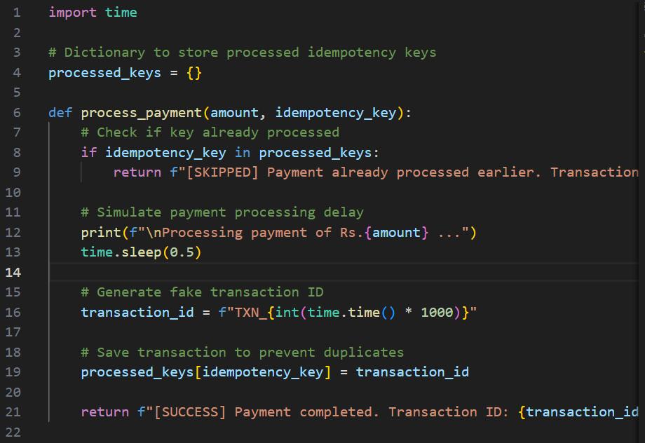

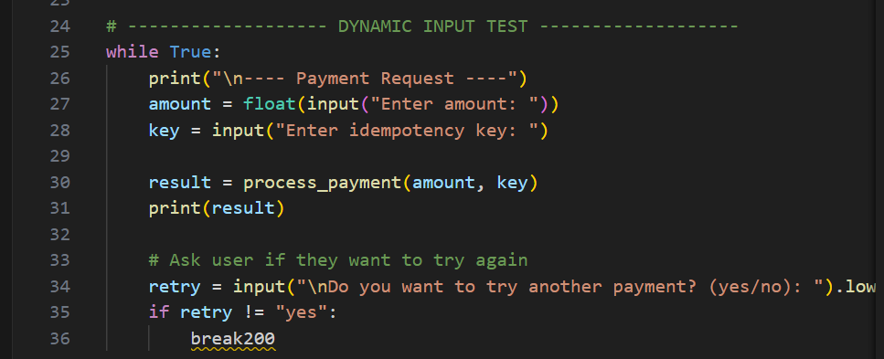
Output:
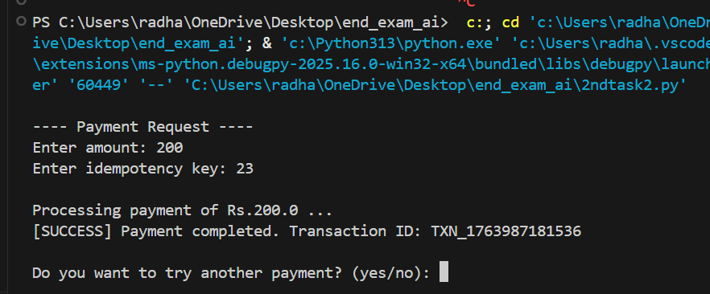
Observation:
The dictionary-based check correctly blocks duplicate payments by returning the original transaction ID.
Since keys never expire or reset, idempotency is consistent across repeated requests.
However, the system lacks thread-safety—parallel requests could still insert duplicates without a lock.
There is no validation for empty or reused keys, which may cause accidental collisions.
Tests should include: same key twice, different keys, rapid repeated inputs, and concurrent calls.

